**Lab 3**

|  |  |  |  |
| --- | --- | --- | --- |
| Student Name | | Student CSUSM ID | Contribution percentage |
| 1 | Lauren Gonzalez | gonza823 | 50 |
| 2 | Sirena Murphree | murph135 | 50 |

**Grading Rubrics (for instructor only):**

|  |  |  |  |  |
| --- | --- | --- | --- | --- |
| Criteria | 1. Beginning | 2. Developing | 3. Proficient | 4. Exemplary |
| Modeling | 0-14 | 15-19 | 20-24 | 25-30 |
|  |  |  |  |
| Program: functionality  *correctness* | 0-9 | 10-14 | 15-19 | 20 |
|  |  |  |  |
| Program: functionality  *Behavior Testing* | 0-9 | 10-14 | 15-19 | 20 |
|  |  |  |  |
| Program: quality ->  *Readability* | 0-2 | 3-5 | 6-9 | 10 |
|  |  |  |  |
| Program: quality ->  *Modularity* | 0-2 | 3-5 | 6-9 | 10 |
|  |  |  |  |
| Program: quality ->  *Simplicity* | 0-2 | 3-5 | 6-9 | 10 |
|  |  |  |  |
| Total Grade (100) |  | | | |

**Problems:**

A video game has three modes: beginner, intermediate and advanced. For each mode chosen by a player, the game GUI shows two control objects: a character selection panel and a weapon selection panel. Note that (a) under different modes the system displays different character selection panels and weapon selection panels, and (b) it is possible that new modes and/or new control objects may be added in the future.

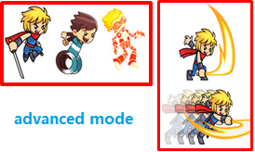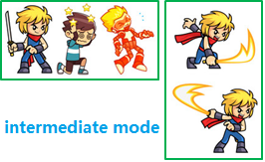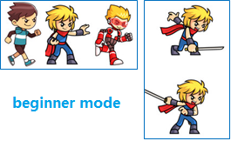

1. Apply a design pattern to design the system such that the model can be easily extended to cover future changes without affecting the code on the client side. You should use a UML class diagram to document your design.
2. Write Java code to implement your design. You should have a simple test class to show how it works.

**Solution:**

* First, remember to zip the src folder of your project and submit the zip file to the ungraded assignment named “Lab3CodeSubmission”. One submission from each team.
* Paste a screenshot of a run of your program here.
* Also paste all you source code here.
* Save this report in PDF, then **each student** needs to submit the pdf report to the graded assignment named “Lab3ReportSubmission”.

